Lewis University  
CPSC 50900: Database Systems  
Term Project

World population & migrants database

Vineeth Reddy Gaddam, vineethreddygaddam@lewisu.edu

Prem Kumar Baddam, Premkumarbaddam@lewisu.edu

Sushanth Reddy Teegala, sushanthreddyteega@lewisu.edu

<https://github.com/vgaddam12/Database-system>

Table of Contents

Initial Proposal 2

Data Sources 2

Data Storage Alternatives 2

Relational Database Design Process 3

Relational Database Design 3

Data Definition Language (DDL) Scripts 3

Data Manipulation Language Scripts 4

Indexes 5

Views 5

Triggers 5

Transactions 5

Database Security 6

Locking and Concurrent Access 6

Backing Up Your Database 6

Python Programming 7

PHP Programming 7

Suggested Future Work 8

Activity Log 8

# Initial Proposal

*Description: You will describe the data you aim to store. What data will be storing? Why are you interested in this data? Why is it important? Where will the data come from? Who will use this data? What kind of application do you plan to build with it?*

*Rubric: Your response to each of these six questions will be graded out of 3 points.*

* *3 points: clear, complete descriptions that convey the importance and meaning of your data*
* *2 points: mostly clear descriptions, although some additional data would have helped in some sections*
* *1 point: necessary details are lacking in many of your responses.*

*You will also earn 2 additional points for coming up with a descriptive title for your project.*

*Total points possible: 20*

# We will be storing world’s Population, surface area and density. Also, how many people are migrants

We are interested in this data because increasing population is the world’s biggest problem considering the resources are scarce. Also, migrants count will be provided. It is important to keep track of population. Also, how migrants are affecting in population of countries

It is important to keep track of population. Also, how migrants are affecting in population of countries

The data will come from

<http://data.un.org/>

Governments will use this data to keep control of their population

An informative application that may help students or researchers use data in an effective manner.

Title

World population & migrants database

# Data Sources

*Description:* *Gather your data in text files. The text files may be csv, tab-delimited, xml, json, or some other custom format. Not all the files need be of the same type. Identify what each file contains by indicating where it came from, explaining in detail how it structured, and describing how you will reorganize the data into a relational database. Post your data files to your GitHub repository, and provide samples of the data in your Word doc.*

*Rubric: Your work will be graded as follows:*

* *5 points: you gathered multiple data files that contain the data that will populate your databases. If you do not use multiple data files, you will not receive credit.*
* *5 points: you described the contents of the data files in detail, including referencing their origin and explaining how they were structured.*
* *3 points: you identify which fields you plan to include in your database, including their data types and any constraints you expect to impose on the data or steps you'll have to take to clean up the data.*
* *2 points: you post the data files to your GitHub account and make it possible for me to see them.*

*Total points possible: 15*

Gathered data in csv files from UN website. Data files contain world population by regions and overall as well and they contain number of refugees in divided by sexes, people who seek asylum etc. We are planning to include number of migrants grouped by regions and population overall of those regions.

Id(int, primary key, Unique, [NOT NULL](https://www.tutorialspoint.com/sql/sql-not-null.htm))

Region(string(100))

Population(integer)

Refugees(integer)

# Data Storage Alternatives

*Description: We will study alternatives to storing data in a relational database. Some of the alternatives come from several decades ago, including the hierarchical and network models. Some are newer options, such as NoSQL databases that use JSON or some other encoding. Describe in detail how to store the data using two alternatives to relational databases. Be sure to describe how you would implement the alternatives and the advantages and disadvantages of each.*

*Rubric: Your work will be graded as follows*

* *5 points for clearly describing how your data could be stored using one alternative to relational databases and what the advantages and disadvantages of that approach would be.*
* *5 points for clearly describing how your data could be stored using another alternative to relational databases and what the advantages and disadvantages of that approach would be.*

*Total points possible: 10*

Hierarchical Data Model:  
Contains nodes which are connected by branches

The topmost node is called the root node.

Each node has exactly one parent

If there are multiple nodes appear at the top level, then these can be called as root segments.

Records are linked with the help of pointers.

One parent may have many child.

Disadvantages:

Insertion anomaly exits in this model i.e. child node cannot be inserted without the parent node.

Deletion anomaly exists in this model i.e. it is difficult to delete the parent node.

This model lacks data independence.

Network Data Model:

In this model, you could create a network that shows how data is related to each other

It implements 1:1, 1:n and also many to many relations.

To organize records, it uses graphs

Records are linked with the help of linked list.

There is no insertion anomaly.

Disadvantages

There is partial data independence in this model.

# Relational Database Design Process

*Description: Consider the list of fields you identified in part c. Identify functional dependencies that exist among them. For each functional dependency, identify the determinants and the fields they determine. This becomes the basis for identifying your entity sets, which then become your tables. Give each entity set or table you identify in this way a unique and clear name, making sure that the names you use are singular nouns. Then list the relationships that exist among the various entity sets. For each relationship, identify its connectivity (one-to-one, one-to-many, many-to-many) and participation (optional or mandatory). Finally, make sure that none of the attributes you've assigned to each entity set are multi-valued. If they are, take the steps needed to break them down.*

*Rubric: Your work will be graded as follows:*

* *8 points for identifying all the functional dependencies, including determinants and the columns whose values they determine.*
* *2 points for naming the entity sets that make up your data with clear, easy-to-understand names.*
* *6 points for identify the relationships among the entity sets and identifying connectivity and participation for each.*
* *2 points for breaking down multi-valued attributes.*

*Total points possible: 18*

Functional dependencies

1. In population,surface area:

RegionCode,Country/area,year---->value

1. In migrants and Refugees:

RegionCode, Country/area, year, Series---->value

Naming entity sets:

Population

Migrant

Relationship among entity sets:

# 

# Relational Database Design

*Description: This is where you will complete your database design. For each of the entity sets you identified in the preceding section, analyze them to make sure they pass 2nd, 3rd, 4th, and Boyce-Codd Normal Form. If they do not, introduce additional entity sets or key changes to make sure that they do. Then, add foreign keys to connect entity sets that are related. For many-to-many relationships, introduce bridge entity sets to convert them into two one-to-many relationships. Also, consider whether you should introduce surrogate keys to create a more efficient primary key for some of your entity sets. Finally, diagram your design in Vertabello. Make sure your ER diagram correctly shows all entity sets, their primary and foreign keys, the data types for each attribute, and the connectivity and participation characteristics of each entity set. Your final Vertabello design should be something you could actually implement in a relational database management system.*

*Rubric: Your work will be graded as follows:*

* *4 points for the normalization analysis of your entity sets.*
* *3 points for introducing bridge entity sets.*
* *3 points for choosing foreign keys and perhaps more efficient surrogate keys*
* *10 points for correctly depicting your physical database model in Vertabello*

*Total points possible: 20*

*4th normal form*

# 

# Physical database design

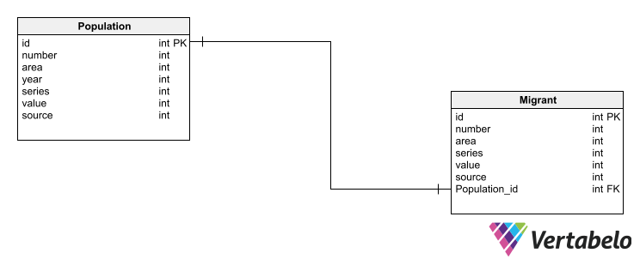

# Data Definition Language (DDL) Scripts

*Description: Use Vertabello to generate a script of SQL commands that build the database and its table structures. Write scripts or build Excel spreadsheets that take your data files and generate scripts of SQL insert statements from them. Use the MySQL source command to run the various scripts needed to build and populate the database in MySQL. Include the source code and / or Excel spreadsheets you use to manipulate and populate the data. Make sure all your tables have at least three records in them and that you've linked the tables through their foreign keys.*

*Rubric: Your work will be grades as follows:*

* *Database and table creation statements from Vertabello saved as an sql script file: 3 points*
* *Scripts you write or Excel spreadsheets you create to generate SQL commands for populating the tables, uploaded to GitHub: 8 points*
* *Descriptions of the scripts and Excel spreadsheets you wrote along with code excerpts included in the Word document: 5 points*
* *Screenshots of your successful attempts to use the MySQL source command to populate each table with at least three records: 4 points*

*Total points possible: 20*

Vertabello has helped my generate sql commands which will help me create actual database tables with constraints applied.

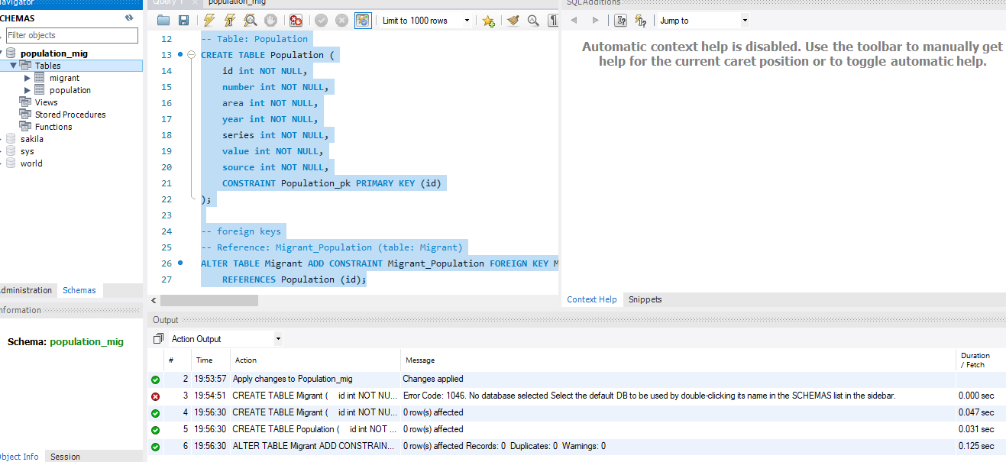

# Data Manipulation Language Scripts

*Description: Write the SQL commands for twelve queries. Two queries should be insert statements, two should update statements, one should be a delete statement, one should be a simple select statement that selects a subset of the rows and columns from one table, two should be a select statements that select data from a joining of two tables, two should use summary functions to generate statistics about the data, one should be a multi-table query, and one should be another query of your choice. Show the queries and screenshots of the results in your Word document, and save your queries in a commented sql script to GitHub.*

*Rubric: Your work will be graded as follows:*

* *1 point each for the two insert statements*
* *1 point each for the two update statements*
* *1 point for the delete statement*
* *1 point for the simple select statement*
* *2 points each for the 2 join statements*
* *2 points each for the two that use summary statements*
* *2 points for the multi-table query*
* *2 points for the query of your choice.*
* *12 points for showing the query and a screenshot of the corresponding result set back-to-back for each of these queries in your Word document.*

*Total points possible: 30*

*INSERT commands*

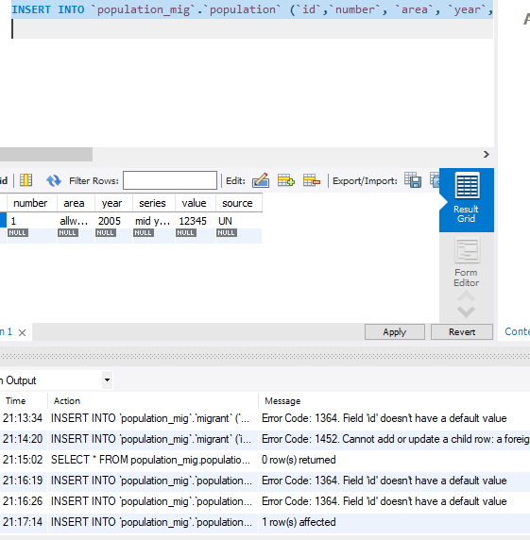

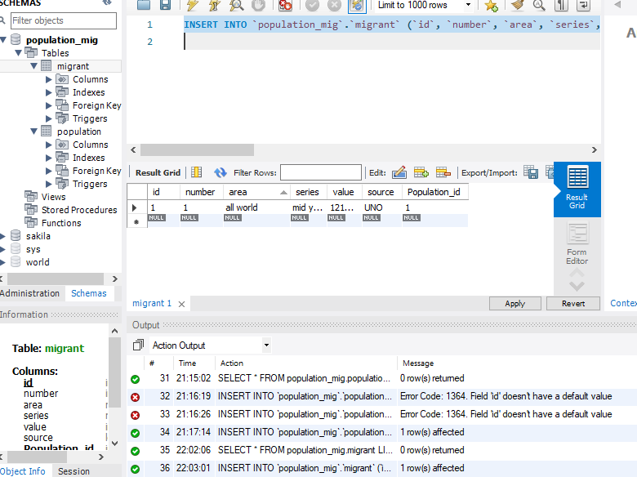

Updates commands

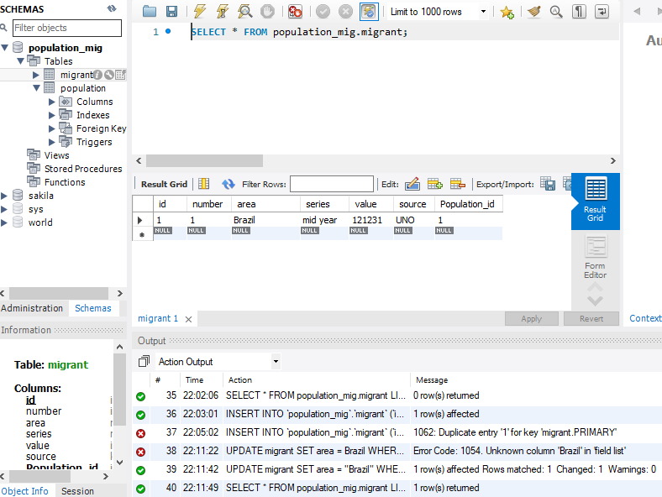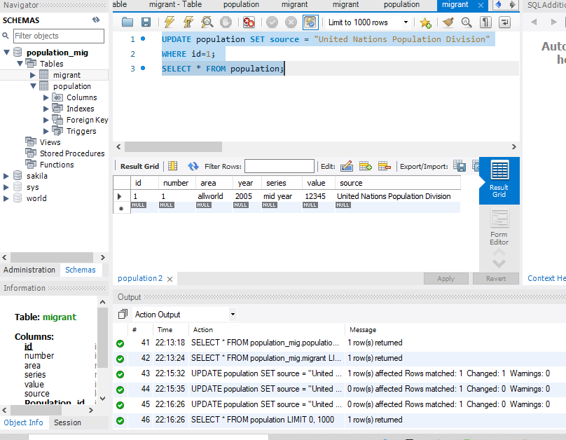

Delete command

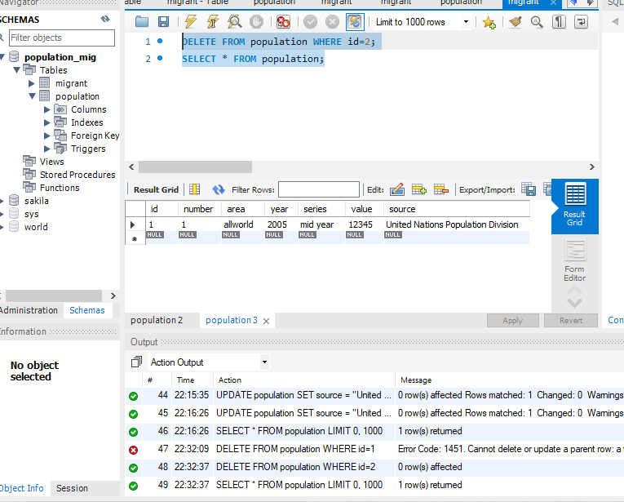

SELECT command

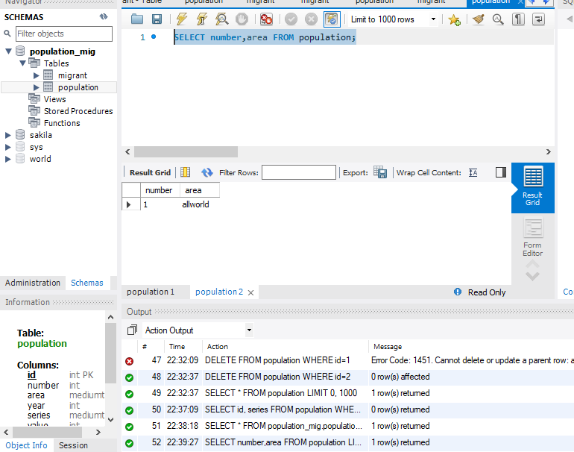

JOIN commands

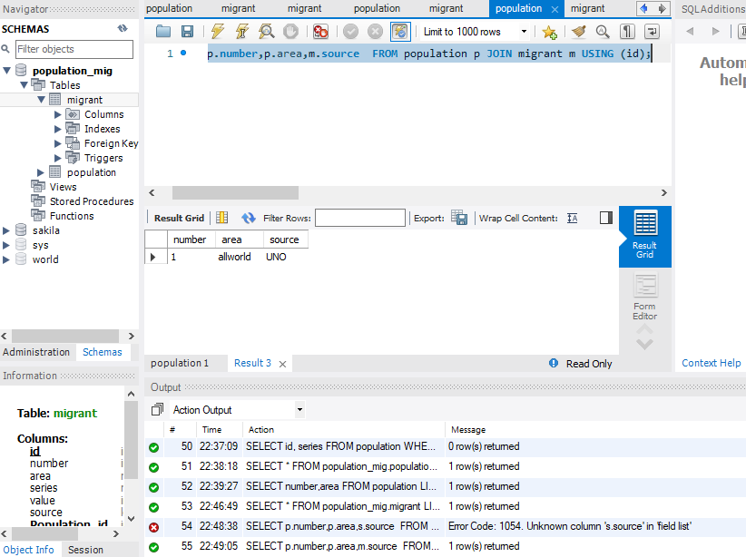

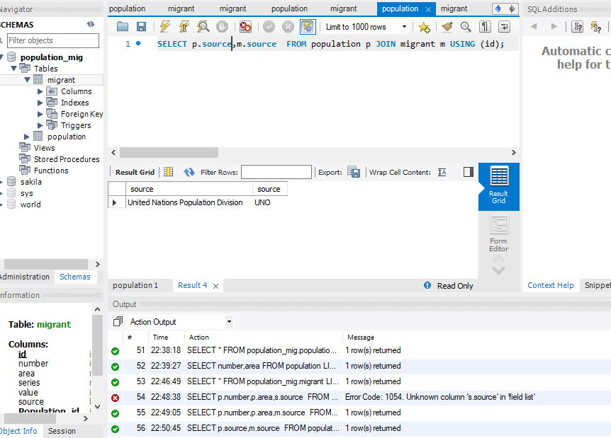

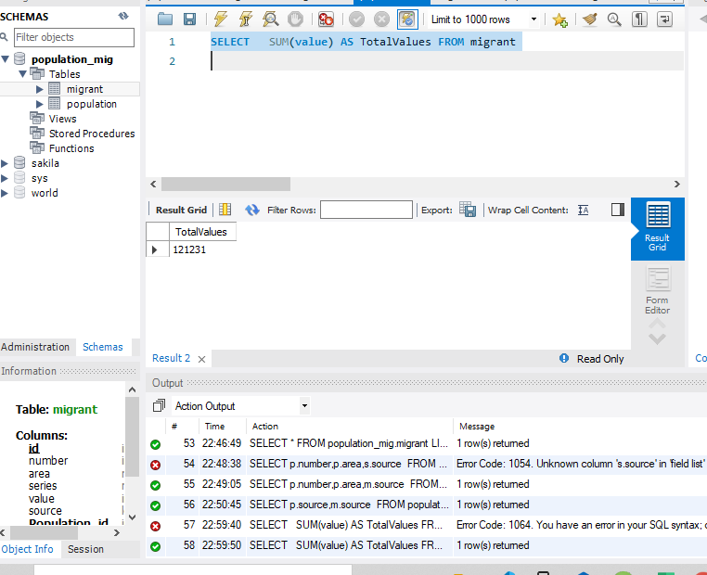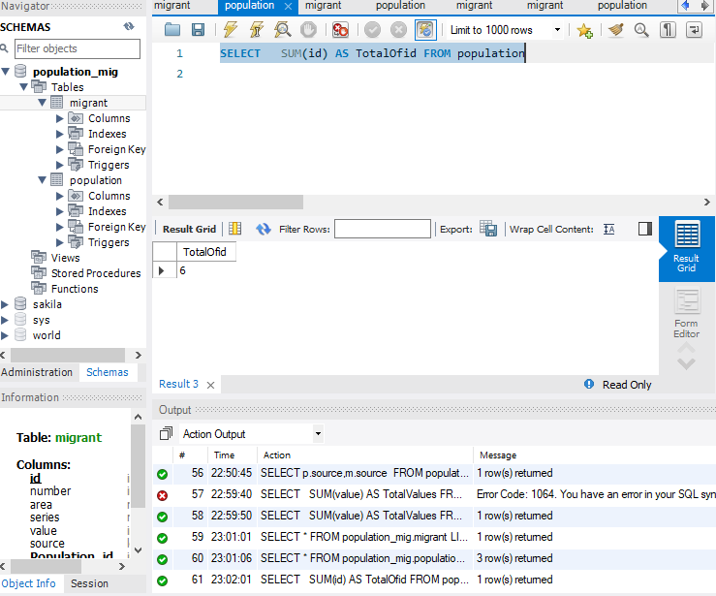

Query of choice:  
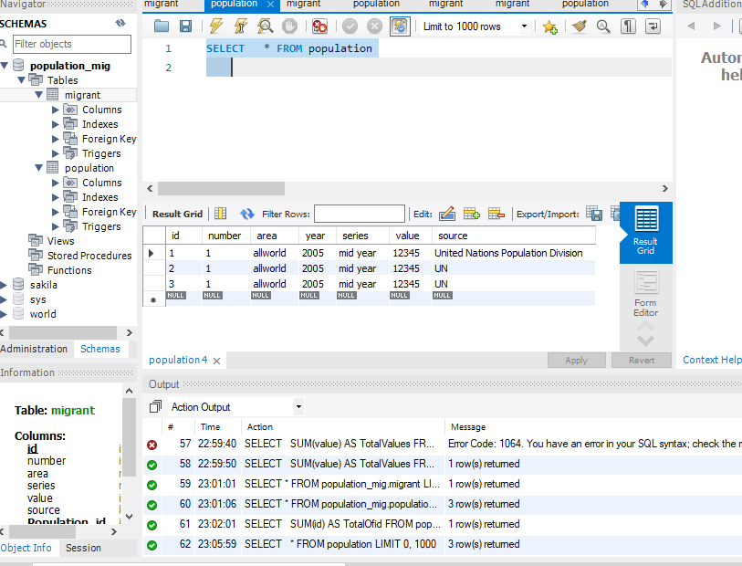

# Indexes

*Description: Improve the performance of your design by adding indexes to various tables. Show the SQL needed to add the indexes. Explain why you chose the ones you added. Explain how you would demonstrate the impact the indexes had on the performance of various queries.*

*Rubric: Your work will be graded as follows:*

* *6 points for clearly defining at least three indexes and explaining why you chose them.*
* *3 points for showing the sql needed to generate the indexes*
* *3 points for explaining how you would demonstrate the performance improvement afforded by the indexes.*

*Total points possible: 12*

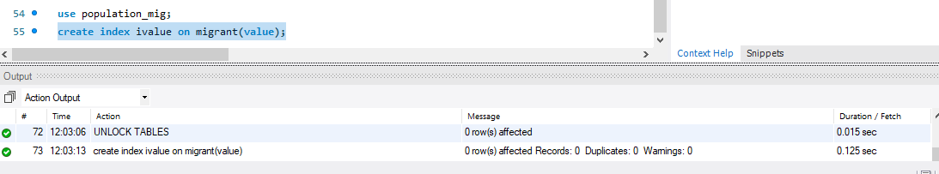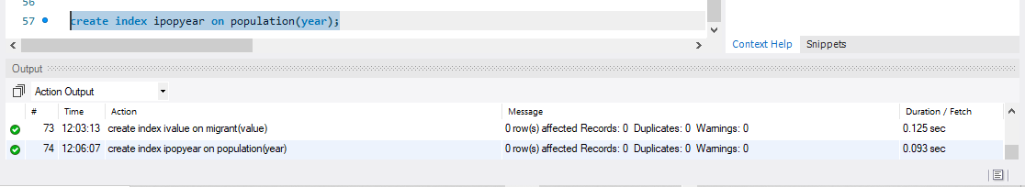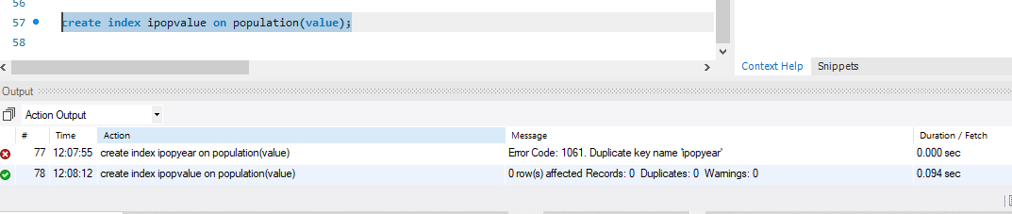

These indexes make querying data faster when it comes to filtering by columns other than primary keys

# Views

*Description: Add two views to your database to provide easy access to combinations of data from multiple tables.*

*Rubric: Your work will be graded as follows:*

* *2 points for including the SQL for generating the two views in your Word document*
* *2 points for including screenshots for the data contained in each view in your Word document*
* *2 points for explaining why each view is a valuable addition to your database*
* *2 points for explaining who might benefit most from having access to each view.*

*Total points possible: 8*

This view join two tables

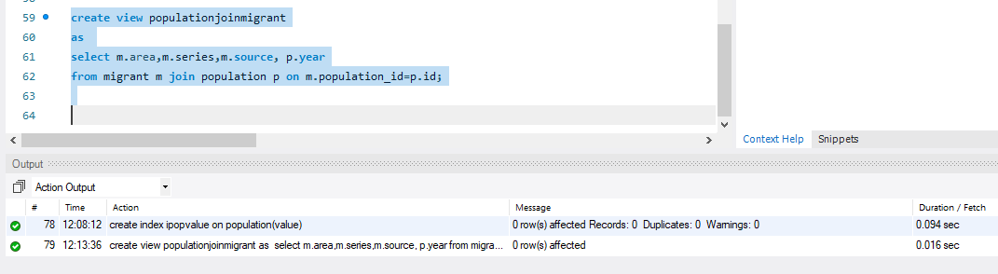

This view is used when grouping by values

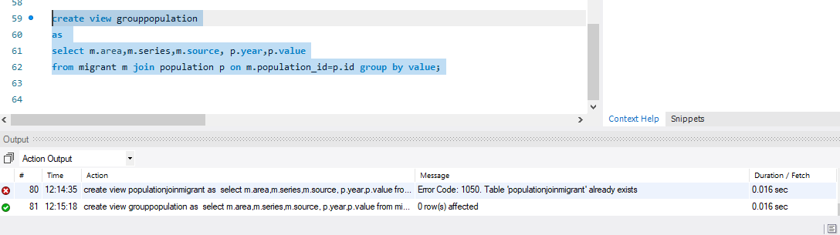

# Triggers

*Description: Add a trigger to a table so that data will be updated when a certain event occurs*

*Rubric: Your work will be graded as follows:*

* *2 points for including the SQL for the trigger in your Word document*
* *2 points for clearly explaining the purpose of the trigger*
* *2 points for a screenshot and explanation that shows the trigger in action.*

*Total points possible: 6*

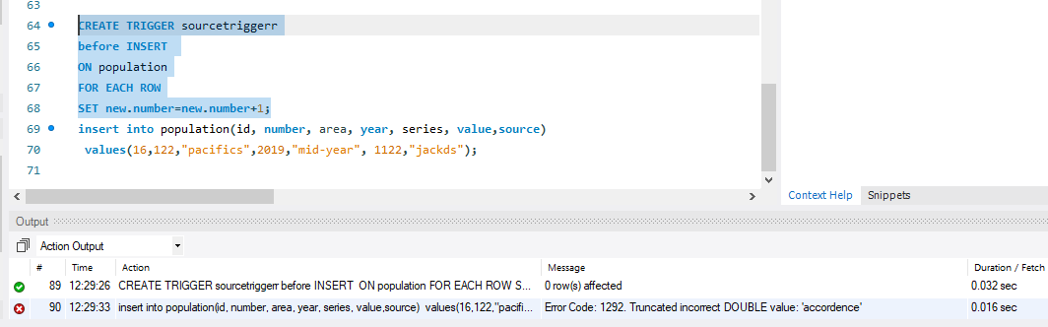

Trigger is used to perform an action based on another action.

# Transactions

*Description: Demonstrate that you know how to define and use a transaction. Why are transactions important for ensuring ACID behavior?*

*Rubric: Your work will be graded as follows:*

* *3 points for clearly explaining the importance of transactions to ensuring ACID behavior*
* *3 points for including a screenshot and accompanying explanation of a MySQL transaction.*

*Total points possible: 6*

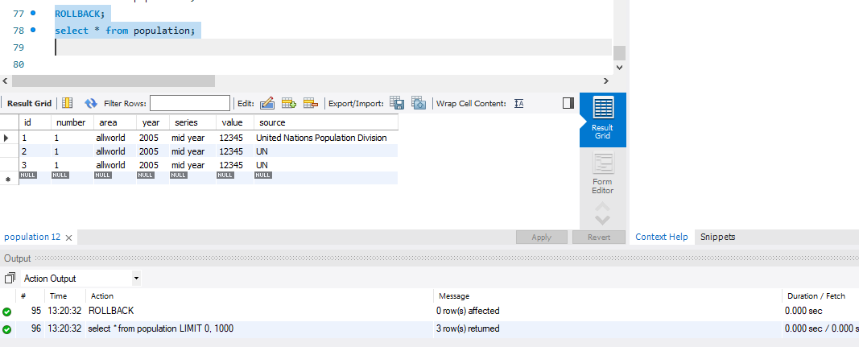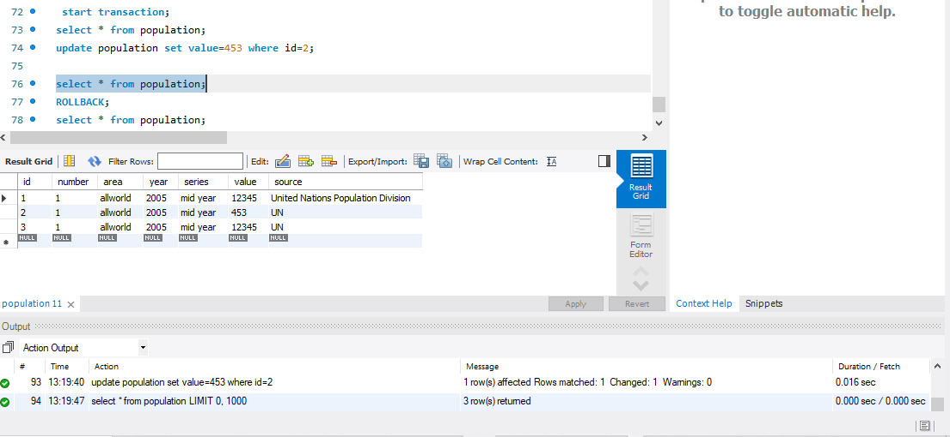

Transaction Group together multiple statements so that they are either all done, or none are done.

This makes sure ACID behavior which is consistency in data, atomicity, isolation, and durability

# Database Security

*Description: Identify the different kinds of users who will use your database. Write GRANT statements to define the privileges for these different kinds of users.*

*Rubric: Your work will be graded as follows:*

* *6 points for clearly identifying and describing the various kinds of users who will use the databases and identifying and justifying what privileges each should have.*
* *4 points for writing GRANT statements that assign privileges to these different kinds of users.*
* *4 points for demonstrating with screenshots that your GRANT statements do distinguish among different kinds of users in regard to what they can do with the database.*

*Total points possible: 14*

Vineeth is a user with all privileges

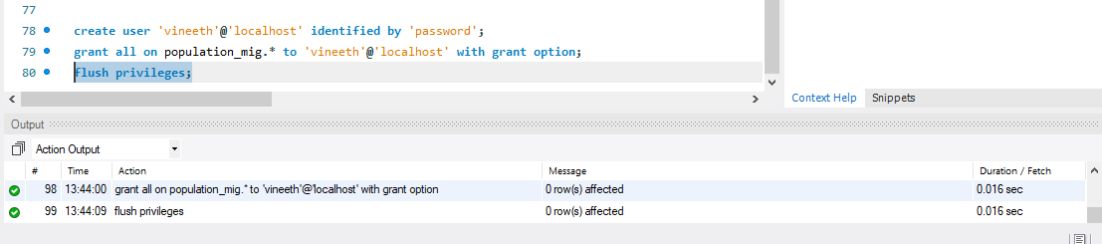

Premkumar has privileges of selecting data only

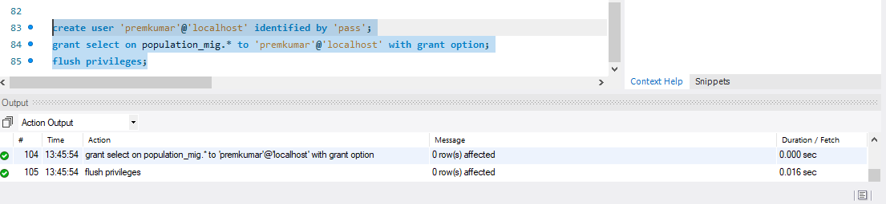

# Locking and Concurrent Access

*Description: Explain the purpose of locking tables and show how to do that to prevent inconsistencies that may arise in your data when concurrent transactions take place.*

*Rubric: Your work will be graded as follows:*

* *3 points for clearly explaining an example that shows why you should lock tables to prevent inconsistencies.*
* *3 points for providing a screenshot and accompanying explanation of locking tables.*

*Total points possible: 6*

We lock table to prevent other user to access/modify tables in database

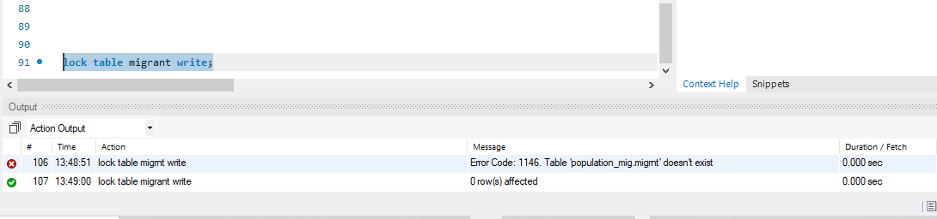

# Backing Up Your Database

*Description: How you will back up your database. What commands will you issue? How frequently will the commands run? How can they be automated? Where will the backups be stored?*

*Rubric: Your work will be graded as follows:*

* *12 points for clearly explaining and justifying your database backup strategy, including the frequency with which you will back up the database, how you will automate backups, where you will store them, and how you will secure them. You will earn three points for addressing each factor (frequency, location, automation, and security)*
* *3 points for providing a screenshot of the command you would issue to back up the database and for including a portion of the resulting file.*

*Total points possible: 15*

mysqldump -h localhost -u vineeth -p password population_mig>popMigrant.sql

# Python Programming

*Description: Write a Python program that generates a report that contains a subset of the data from your database. Include the code for your Python program in your Word document, and also post the program to your GitHub repository.*

*Rubric: Your work will be graded as follows:*

* *12 points for writing a Python script (and including its code in the Word doc) that will pull data from a database and store it to a text file and present it to the screen. Your code must have comments in it that explain how it works. You will be awarded 3 points for successfully connecting to the database, 3 points for successfully querying it, and 4 points for presenting the data to the screen and to a file. Internal comments count for 2 points.*
* *2 points for posting the code to GitHub*
* *4 points for showing a screenshot of your running the script and showing the results it produces on the screen.*

*Total points possible: 18*

ENTER YOUR PYTHON DATABASE PROGRAMMING WORK HERE

# PHP Programming

*Description: Build an HTML form that enables the user to specify criteria to search by. Use PHP to show the results of the query on a resulting web page. Make sure you include protections against an SQL injection attack. Include your HTML and PHP code in your Word document, and also post the files to your GitHub repository.*

*Rubric: Your work will be graded as follows:*

* *4 points for writing an HTML form the user will use to enter search criteria*
* *8 points for a PHP script that uses the search criteria and returns results*
* *4 points for an HTML page that shows the results*
* *4 points for explaining what SQL injection might be run on your website and explaining how you prevented it.*
* *4 points for providing screen shots of your PHP website in action.*
* *2 points for posting your code to GitHub*

*Total points possible: 26*

ENTER YOUR PHP DATABASE APP PROGRAMMING WORK HERE

# Suggested Future Work

*Description: Describe the limitations of your current database and explain how you or someone else could improve the design to address these shortcomings. Also describe how you might take advantage of leverage cloud services to increase the performance and availability of your database. Finally, explain the advantages and disadvantages of storing your data in a NoSQL format instead.*

*Rubric: Your work will be graded as follows:*

* *3 points for clearly describing the limitations of your databases*
* *3 points for explaining how you would address these shortcomings*
* *3 points for explaining how you might migrate the database to the cloud and describing what advantages you might gain from doing that.*
* *3 points for explaining the advantages and disadvantages of storing your data in a document-based NoSQL format instead.*

*Total points possible: 12*

We can only access this database in localhost at the moment we will deploy it onto some remote server and use it through UI created for web.

With using nosql we will be able to handle large volumes of data at high speed with a scale-out architecture.

We will be able to easily update schema in nosql.

We will take advantage of cloud to deliver zero downtime.

# Activity Log

*Description: As an appendix, the team will keep a daily diary or log of their activity. What did you or your team study in this class each day? What did you learn? What did you accomplish or build or design? You don't have to enter something every day, but there should be at least three entries each week. Since we have eight weeks, that means you should make 3 posts to the Activity Log each week, for a total of at least 24 posts. Each post will be worth 1 point.*

*If you are working as part of a team, make sure you clearly identify which team member worked on which tasks. The Activity Log should help me figure out how each team member contributed to the project. If I cannot discern who worked on what aspects of the project from the activity log, no points will be awarded for it.*

*Total points possible: 24*

Vineeth Reddy Gaddam found the data source. Data description was also completed

Premkumar baddam attached the data to csv files.

Sushanth Reddy Teegalaresearched and described the techniques to store data in relational databases

Vineeth Reddy Gaddam did the design till ERdiagram

Premkumar baddam worked DDL

Sushanth Reddy Teegala worked with DML

Vineeth delivered indexes work.

Premkumar-Views

Sushant-Trigger, transaction, future work

Vineeth-Security locking, backup